**Scope Management Plan**

**D7 Auto Service center web-app**

**D7 auto service center**

**C.M. DE LOS REYES AVE. GEN. TRIAS,**

**CAVITE 4107**

**April 2023**

## TABLE OF CONTENTS

Introduction 4

Scope Management Approach 5

Roles and Responsibilities 5

Scope Definition 7

Project Scope Statement 7

Work Breakdown Structure 8

Scope Verification 9

Scope Control 10

Sponsor Acceptance 11

## LIST OF TABLES

Table 1 Roles and Responsibilities 5

## LIST OF FIGURES

Figure 1 Work Breakdown Structure (WBS) 10

# Introduction

Throughout the course of the D7 Auto Service Center Web-App life cycle, the scope of the work will be defined, validated, regulated, and verified according to the guidelines in the scope management plan. The scope management plan’s goal is to guarantee that the project stays on course and fulfills its intended scope within the set timetable and budget.

To create the scope management plan for the D7 Auto Service Center, the team will apply the five-step process of Project Scope Management, which includes collecting requirements, defining scope, creating a WBS (Work Breakdown Structure), verifying scope, and controlling scope.

1. **Collect Requirements** - The team will be defining and documenting the requirements necessary to achieve the project objectives. Both the project charter and stakeholder registration will serve as the foundation for the collection of requirements, which will also enable the team to define requirements, discuss details associated with achieving each requirement, and clarify them through interviews and follow-up discussions. To ensure that the project's execution phase can measure the requirements, they will be meticulously recorded. As part of the process of establishing the project scope, the documentation produced during this step will also be used as input.
2. **Define Scope and User Stories** – Based on the requirements gathered in the collection process, the project scope is defined in detail. This process includes creating the scope statement, developing the project charter, and identifying the deliverables and requirements for each work deliverable.
3. **Create a Work Breakdown Structure (WBS)** - With the help of a WBS, the project scope is segmented into smaller, more manageable work packages. This is utilized to facilitate the project team's ability to effectively manage the project by breaking down the scope into comprehensible components. The resulting WBS visually represents the scope of the project and makes it more accessible to all team members.
4. **Verify Scope** - In this step, the project deliverables are examined and validated to make sure they adhere to the specifications outlined in the project scope statement. This step helps ensure that the project progresses according to schedule and that the project deliverables satisfy stakeholders' demands.
5. **Control Scope - Throughout the project's lifecycle, this phase requires monitoring and regulating changes to the project's scope.** This includes the team handling scope adjustments and any scope creep that might happen while the project is being carried out.

# Scope Management Approach

The Scope Management Approach for the project is the following:

1. **Authority and Responsibility for Scope Management:**

The Project Manager, Andre O. Viernes, has the primary authority and responsibility for scope management, while the Project Sponsor, Anne Sydney Simpelo, will provide support and guidance as needed to complete the project within its given scope and period throughout the team’s PBL (Project Based Learning) journey.

1. **Scope Definition:**

To accurately define the project scope of the project, the Elite Four team will use several documents to define this matter, and these are but might not be limited to: the Scope Statement, Statement of Work, Work Breakdown Structure, WBS Dictionary, and other relevant materials that will provide a detailed understanding of the project's scope, its objectives, requirements, and deliverables.

1. **Scope Measurement and Verification:**

To clearly identify the project’s measurement and verification it will be measured through the following:

* + Success Criteria – These criteria will be of use to determine whether the scope of work is within line, and it will be used to also measure the completion of the project within its scope
  + Project Sponsor Approval – The pivotal approval of the project sponsor of the project will be the means of verification whether the project being developed was not any less nor exceeded its scope as intended within the premises of the project sponsor’s recommendations, approval, and restrictions.

1. **Scope Change Process:**

The project manager, Andre O. Viernes, as well as all the other team members, have the authority to change the project's scope as much as necessary, and accordingly. However, before making any modifications by any means, the project manager together with the team will consider the possible impacts on the project's schedule, budget, and other factors and will request permission from the project sponsor, Ms. Anne Sydney Simpelo to push through any changes that will be made to the project.

1. **Acceptance of Final Project Deliverable(s):**

The final project deliverable must be accepted, and the project scope must be approved by the project sponsor, Anne Sydney Simpelo. Andre O. Viernes, the project manager, will ensure that all project deliverables have been completed in line with the scope statement and that the Project Sponsor is fully notified of any changes made throughout the project. To guarantee that all project deliverables fulfill the acceptance criteria and receive final approval, the project manager will also collaborate closely with the project sponsor.

# Roles and Responsibilities

The roles and responsibilities of the team are as follows:

Table Roles and Responsibilities

|  |  |  |
| --- | --- | --- |
| **Roles** | **Who** | **Responsibilities** |
| Project Manager | Andre Viernes | In charge of overseeing the team and ensuring the project is planned, executed, and tasks are completed successfully & on time. |
| Product Owner | Dan Michael Alfaras | Guides and supports team members to successfully complete the project within the given constraints. |
| Team Developer | Alyssa Garcia | Works closely with the Product Owner. In charge of designing, coding, testing, and implementing the project that the team is working on. |
| Team Developer Support | John Zenon Coquia | Works closely with the team’s developer. Assists in designing, coding, testing, and implementing the project that the team is working on. |
| Team Secretary | Francesca Erin Camino | In charge of coordinating communication and documentation, organizing meetings, managing schedules, and ensuring that participants and roles are defined for the business case and throughout the project. |
| Team Secretary Support | Darrell Royce Lazala | Works closely with the team’s secretary, providing administrative support to the team and assisting in the coordination of team activities. |
| Project Sponsor/Stakeholder | Anne Sydney Simpelo | In charge of providing the necessary resources for the project, defining the project's objectives, monitoring its advancement, and ensuring its success in achieving its objectives and delivering business value. |

# Scope Definition

The project’s scope definition will be comprised of where the project is limited to, and what it is intended to do, followed by the approval of the project sponsor, and compliance within the requirements of the PBL (Project Based Learning) of the Elite Four. These were identified to be:

* Creation of the Web-App as an additional online presence for D7 Auto Service Center
* Creation of a booking system that will allow D7 Auto Service Center to manage bookings online made in the web-app and customer to request for bookings 24/7 (except when system downtime occurs.)
* Implementation of helpful features that will allow D7 Auto Service Center to promote rapport with their customers.

The scope is subject to change if either the team or the project sponsor made agreements regarding changes, as the project follows an Agile methodology, which may have or pose changes during the project’s development phase and/or its entire cycle.

# Project Scope Statement

**Product Scope Description**

The D7 Auto Service Center Web-app project will be limited to creation of an additional platform for D7 that will extend their online presence, as well as creation of a booking system that allows D7 and their customers to manage and make reservations, respectively.

**Product Scope Deliverables**

The deliverables of the project will be as follows:

1. A fully working web-app for D7 Auto Service Center
2. A fully working online booking system, a feature of the web-app
3. A manual that will provide instructions on how the web-app will be used.
4. A documentation of the project’s product backlog, set of features, and agreed scope, its records, approvals, and other pertinent documents that is within the scope of the Elite Four’s documentation.

**Product Acceptance Criteria**

The Product Acceptance Criteriafor the client’s receivable project are as follows:

1. All the needed documents are completed and approved by the project sponsor and subject adviser to proceed to the phases of the project.
2. The development team has completed all the features and functionalities as per the product backlog and has ensured there are no bugs or problems (at least before deployment).
3. The Web-App deployment was successfully completed by D7 Auto Service Center, indicating the application is ready to be used by end-users.
4. During the User Acceptance Testing, users have provided positive feedback about the Web-App, indicating that the application meets their requirements and is user-friendly.
5. The personnel of D7 Auto Service Center including that of the owner and the project sponsor is taught of how the web-app is and will be used for the business itself.

**Project Exclusions**

The project exclusions for the project are as follows:

1. No work will be done for support after the web-app's initial release and launch.
2. The creation of content, including text, images, and videos, is not part of the project scope and is under D7’s control.
3. Legal or regulatory compliance work, such as obtaining licenses, permits, or certifications, as well as payments for the deployment is beyond the project's scope.
4. Bug fixes or troubleshooting beyond the web-app's initial release are not included in this project.
5. Optimization of the web-app's performance beyond the initial is not part of the project scope.
6. Any work related to backup and restoration procedures is not part of the project scope.

**Project Constraints**

The project constraints for the project are as follows:

1. Time Constraint: The project must be completed within the duration of the PBL course, and any other extension must be approved by the subject adviser.
2. Budget Constraint: The project must be completed within the approved budget, which is allocated by the project sponsor.
3. Manpower Constraint: The project team consists of 6 members, and no additional member can be added to the team without approval from the subject adviser.
4. Resource Constraint: The project team must use resources efficiently and effectively to ensure that the project is completed within the time and budget constraints.
5. Communication Constraint: The project team must communicate effectively and with the project sponsor for any changes to the project scope, schedule, budget, etc.
6. Quality Constraint: The project deliverables must meet the agreed-upon quality standards, and any deviations from these standards must be approved by the subject adviser, project panelist(s), and project sponsor.

**Project Assumptions**

The following list includes the project’s preliminary assumptions:

* The development team has the technical knowledge and proficiency required to successfully complete the project in accordance with the specifications.
* The client has provided clear and concise project requirements, and the development team has a thorough understanding of these requirements.
* The project budget and timeline are reasonable and realistic considering the scope of work involved.
* The hardware and software infrastructure required for the development and deployment of the web-app is available and can meet the project’s needs.
* The client is committed to providing timely feedback and approvals during the development process to ensure smooth progress and timely decision-making.
* The web-app will undergo comprehensive testing before deployment to ensure that it meets all functional and non-functional requirements and is of high quality.
* The development team will use an Agile project management approach to ensure effective project execution by providing flexibility and adaptability to changing requirements and conditions.
* Any project-related legal or compliance obligations are acknowledged, and they will be followed throughout the project's duration.
* The project team has access to the necessary resources, tools, and technology required for the project's successful completion.

Throughout the project, these assumptions will be reviewed and updated often to maintain their accuracy and relevance and to proactively address any changes or inconsistencies that might influence the project's success.

# Work Breakdown Structure

The WBS is used to break down the project scope into smaller, manageable deliverables that are tracked throughout the project's life. While, the WBS Dictionary provides a detailed description of each deliverable, including its scope, timeline, cost, and quality requirements. The WBS created for the project is shown on the figure below:

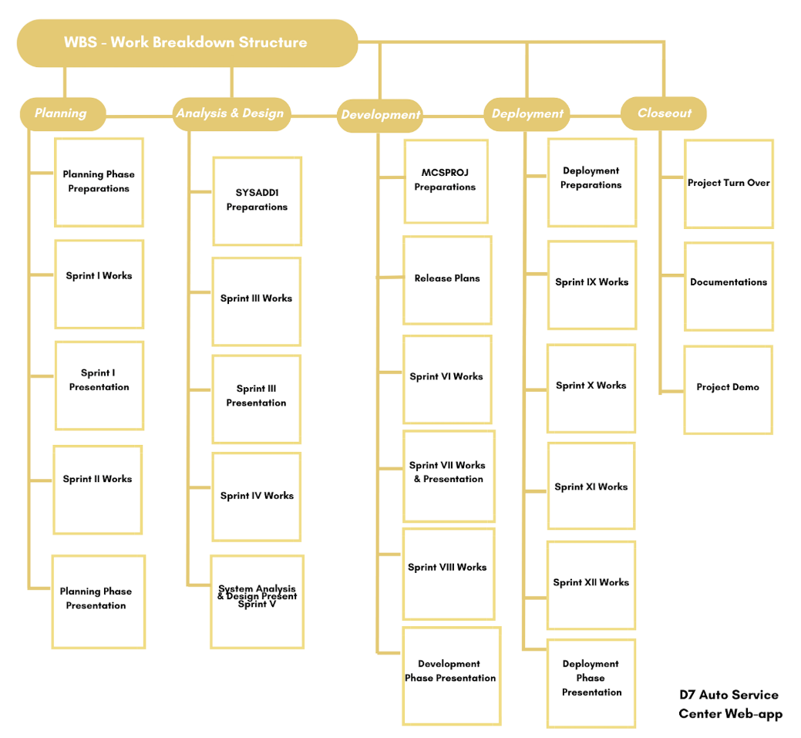

Figure Work Breakdown Structure (WBS)

# Scope Verification

To ensure that all deliverables adhere to the original scope and specifications listed in the scope management plan, the scope verification process will be carried out. The project team will collaborate with the client and other key parties to guarantee that all needs have been met, and a precise checklist will be prepared for the acceptance requirements for each deliverable. Any deviations from the scope management plan will be noted and dealt with in consultation with the appropriate parties. The project team will receive formal sign-off from the client after confirming and accepting all deliverables before proceeding to the next stage.

# Scope Control

Within the project’s scope control, is the planning of the project itself, the system analysis and design of the project, the preparation and development of the project, and the deployment of the web-app.

This project will be under control during the PBL or Project Based Learning of the Elite Four team. The Elite Four will not be in control of any actions that the project sponsor and D7 personnel will make upon release of the web-app to the webhosting service.

Any changes that will be made after deployment, may it be through the services, and the other features of the web-app, and cancellation of the webhosting, is not under the control of the Elite Four, but under the control of D7 Auto Service Center and their personnel.

# Sponsor Acceptance

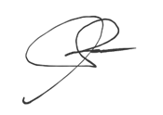Approved by the Project Sponsor:

Date: April 20, 2023

Ms. Anne Sydney Simpelo

D7 Auto Service Center Owner